**2025 CONTRACTOR REGISTRATION**

In compliance with [Chapter 1452](https://codelibrary.amlegal.com/codes/mentoronthelake/latest/mentorlake_oh/0-0-0-47396) of the Codified Ordinances of the City of Mentor-on-the-Lake, all contractors and subcontractors performing work within the City of Mentor on the Lake must register and obtain a license to do so. Please complete all paperwork before submitting.

* **Certificate of Registration Application**
* **Registration Bond** - $10,000
* **Certificate of Insurance Coverage** - $1,000,000.00 Liability and $1,000,000.00 Property Damage
* **CCA Municipal Tax Form**
* **$50.00 Registration Fee**
* $5.00 Sign Permit (Optional) *This allows the business to display their sign on the property while working on the job and up to 10 days after completion.*

For the following contractors: Electrical, HVAC, Hydronics, Plumbing, And Refrigeration

* Pursuant to H.B. 434, the City requires a copy of your state license (If applicable)
* *Details: General contractors performing electrical, HVAC, hydronics, plumbing, or refrigeration require a state license. All other construction contracting work is licensed by local jurisdictions. Check with your city and/or county government for specific licensing requirements.*

[](https://www.oups.org/)All Contractor Licenses are issued by the calendar year.  Registration for 2025 begins December 15, 2024. If you have any questions, please contact me.

Chuck Snyder Jr

Zoning & Housing Administrator

[Zoning@citymol.org](mailto:Zoning@citymol.org)   
(440) 257-7216

[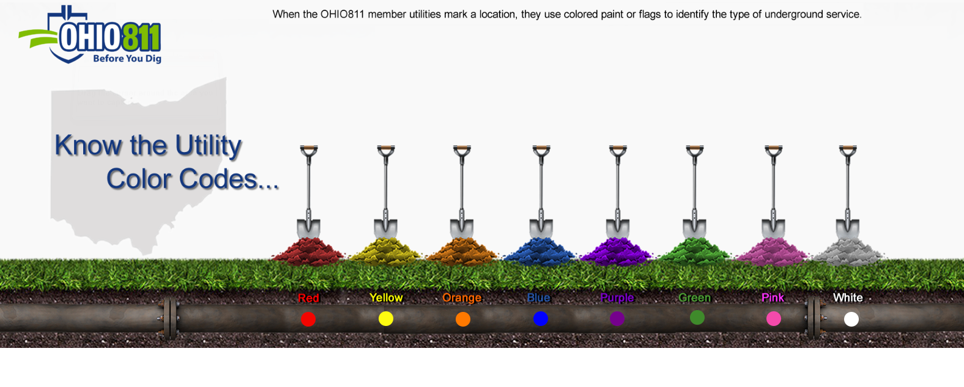](https://www.oups.org/)

**2025 APPLICATION FOR CERTIFICATE OF REGISTRATION**

In compliance with Chapter 1452 of the Codified Ordinances, the following information must be provided for contractor registration.

|  |  |  |  |  |  |  |  |  |  |  |  |  |  |  |  |  |  |  |  |  |  |  |  |  |  |  |  |  |  |
| --- | --- | --- | --- | --- | --- | --- | --- | --- | --- | --- | --- | --- | --- | --- | --- | --- | --- | --- | --- | --- | --- | --- | --- | --- | --- | --- | --- | --- | --- |
| DOING BUSINESS AS: | | | | | | |  | | | | | | | | | | | | | | | | | | | | | | |
| NAME OF APPLICANT: | | | | | | | |  | | | | | | | | | | | | | | | | | | | | | |
| BUSINESS ADDRESS: | | | | | |  | | | | | | | | |  | | | | | | | |  | |  | | | | |
|  | | | | | | NUMBER AND STREET | | | | | | | | | CITY | | | | | | | | STATE | | ZIP | | | | |
| FEDERAL ID OR SS#: | | | | |  | | | | | | | | |  | | | PHONE #: | | |  | | | | | | | | | |
| BUSINESS ORGANIZATION: | | | | | | | | |  | | | | |  | | | CELL #: | |  | | | | | | | | | | |
| [ ]  [ ] | CORPORATION  PARTNERSHIP | | | | | | | | [ ]  [ ] | PROPRIETORSHIP  LLC | | | | | | | FAX #: |  | | | | | | | | | | | |
| EMAIL ADDRESS: | | | |  | | | | | | | | | @ | | |  | | | | | | | | | | | | * | |
| *\* Please provide your email address to receive your Registration Certificate. If you would prefer a mailed copy, you must provide a stamped envelope.* | | | | | | | | | | | | | | | | | | | | | | | | | | | | | |
| CHECK THE TRADE(S) FOR WHICH REGISTRATION APPLICATION IS BEING MADE: | | | | | | | | | | | | | | | | | | | | | | | | | | | | | | |
| [ ] | | General | | | | | | | | | [ ] | Electrical | | | | | | [ ] | | | Plumbing | | | [ ] | | | Roofing | | | |
| [ ] | | HVAC | | | | | | | | | [ ] | Roadway | | | | | | [ ] | | | Tree Service | | | [ ] | | | Underground | | | |
| [ ] | | Other: |  | | | | | | | | | | | | | | | | | |  |  | | | |  | | |  | |
| You must provide your Bond Form in the amount of $10,000, Insurance Certificate in the amount of $1,000,000.00 liability and $1,000,000.00 property damage for each registration. Fee $50. All registrations expire on December 31 of each year. | | | | | | | | | | | | | | | | | | | | | | | | | | | | | | |
| **Paying an additional $5.00 with your contractor registration, permits the contractor to display a business sign on the property while working on the job, and up to 10 days after completion.** | | | | | | | | | | | | | | | | | | | | | | | | | | | | | | |
| I/We hereby certify that I/We are familiar with the provisions of Chapter 1452 of the Codified Ordinances of the City of Mentor-on-the-Lake and are fully aware of the requirements of same. In the event that it is required to sublet work, it is agreed to engage only registered contractors, and that any misrepresentations of data or facts will be case for refusal of a Certificate of Registration or revocation of same. | | | | | | | | | | | | | | | | | | | | | | | | | | | | | | |

|  |  |  |  |  |
| --- | --- | --- | --- | --- |
|  |  |  |  |  |
| Signature of Applicant |  | Title |  | Date |

|  |  |  |  |  |  |  |  |
| --- | --- | --- | --- | --- | --- | --- | --- |
| **FOR OFFICE USE ONLY** | | | | | | | |
|  | |  |  | |  | |  |
| Registration #: |  | | Receipt #: |  | | Sign Permit: Y N | |
|  |  | |  | |  | |  |

REGISTRATION BOND

KNOW ALL MEN BY THESE PRESENTS, that ______________________________________as the principal and ________________________________________________ as surety, hereinafter referred to as the surety, are held and firmly bound unto the City of Mentor-on-the-Lake, in the sum of ten thousand dollars ($10,000.00) for payment of which, well and truly to be made, we bind ourselves, our heirs, executors, administrators, successors and assigns, jointly and severally, firmly by these presents.

WITNESS OUR HAND AND SEAL THIS ______ DAY OF ___________________, _____________.

The conditions of the above obligations are such that:

WHEREAS, the said Principal has been duly licensed or registered for the period beginning ___________________ and ending December 31, 2025, in the City of Mentor-on-the-Lake, Ohio, in accordance with the ordinances of the City of Mentor-on-the-Lake providing for the licensing or registration and regulations of a ________________________ contractor.

NOW, THEREFORE, if the said Principal shall faithfully observe all the duties and discharge all the obligations incurred by him during said license or registration period under the ordinances of the City of Mentor-on-the-Lake and under the provisions of the Ohio Building Codes for residential, commercial and industrial building applying to _____________________ contracting, and all the lawful orders of the Service Department of the City of Mentor-on-the-Lake, issued under said ordinances and all lawful orders of the Lake County Building Department, then this obligation shall be void, otherwise the same shall be and remain in full force and effect; the undersigned agreeing and consenting that this undertaking shall be for the benefit of any party injured by the principal’s failure to comply with the duties, terms, conditions, provisions, and requirements of the ordinances of the City of Mentor-on-the-Lake applying to ______________________ contracting, and the lawful orders of the Department of the City of Mentor-on-the-Lake issued under such ordinances, as well as, for the benefit of the obligee herein, and either or both may bring action on this bond; but, said action must be commenced within two years after the expiration of the principal’s _________________________ contracting license or registration.

|  |  |  |
| --- | --- | --- |
|  |  |  |
| PRINCIPAL |  | SURETY |
|  |  |  |
|  |  | ATTORNEY-IN-FACT |

**WITHHOLDING AND BUSINESS REGISTRATION**

**CCA – MUNICIPAL INCOME TAX**205 W SAINT CLAIR AVE  
CLEVELAND, OH 44113-1503

P: (216) 664-2070, (800) 223-6317 F: (216) 420-8316

[www.ccatax.ci.cleveland.oh.us](http://www.ccatax.ci.cleveland.oh.us)

|  |  |  |  |  |  |  |  |  |
| --- | --- | --- | --- | --- | --- | --- | --- | --- |
| DATE BUSINESS STARTED IN CCA | | | |  | | | PHONE NO |  |
| FEDERAL IDENTIFICATION NUMBER | | | | |  | | | |
| NAME OR CORPORATE NAME | | |  | | | | | |
| BUSINESS OR TRADE NAME | |  | | | | | | |
| BUSINESS ADDRESS IN TAXING COMMUNITY | | | | | |  | | |
| MAILING ADDRESS |  | | | | | | | |
|  | ADDRESS OF OUTSIDE ACCOUNTANT SHOULD NOT BE USED | | | | | | | |

|  |  |  |  |  |  |
| --- | --- | --- | --- | --- | --- |
| CHECK BUSINESS TYPE | | | | | |
|  |  |  |  |  |
| SOLE PROPRIETOR** |  |  | CORPORATION |  |
| PARTNERSHIP |  |  | LIMITED LIABILITY CO |  |
| S-CORPORATION |  |  | NON-PROFIT CORP |  |
| ESTATE OR TRUST |  |  | GOVERNMENTAL |  |
| FINANCIAL ORG. |  |  | UNION |  |
| OTHER |  | (Detail) |  |  |
|  |  |  |  |  |
| **IF SOLE PROPRIETOR YOU MUST ALSO COMPLETE INDIVIDUAL REGISTRATION FORM It is your responsibility to advise this office of any changes in your status | | | | | |

|  |  |  |  |  |  |  |  |  |  |  |  |  |  |  |  |
| --- | --- | --- | --- | --- | --- | --- | --- | --- | --- | --- | --- | --- | --- | --- | --- |
| Will you be withholding employment taxes? | | | Yes |  | | No | |  |  | |  | | | |  |
| For what CCA city(s) | | |  | | |  | | |  | |  | | | |  |
| $200 or more per month? | | | Yes |  | | No | |  |  | |  | | | |  |
| Number of employees in CCA? | | |  | | | | First payroll date in CCA | | | | |  | | |  |
| Will you be withholding residence taxes? | | | Yes |  | | No | |  |  | |  | | | |  |
| Type of business (Mfg., Commercial, etc.) | | |  | | |  | | | | |  | | | |  |
| Fiscal Period ending month | | |  | | |  | | | | |  | | | |  |
|  | | |  | | |  | | | | |  | | | |  |
| Name of person responsible for filing forms: | | |  | | |  | | | | |  | | | |  |
|  | | |  | | |  | | | | |  | | | |  |
| Name |  | | Title | |  | | | | | | Phone No. | | |  | |
|  | | |  | | |  | | | | |  | | | |  |
| Signature | |  | | | | | | | |  | Date | |  | | |